**Confidence scores for each possible classification. Red entries are where the correct classification was not the most confident answer.**

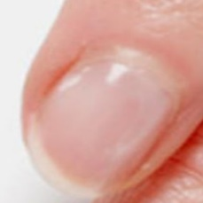  
normal#0 **Confidences:**normal = 80%; serious = 20%; non-serious = 0%;   
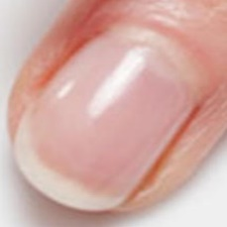  
normal#1 **Confidences:**normal = 100%; serious = 0%; non-serious = 0%;   
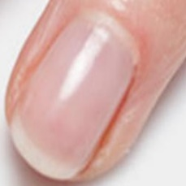  
normal#2 **Confidences:**normal = 100%; serious = 0%; non-serious = 0%;   
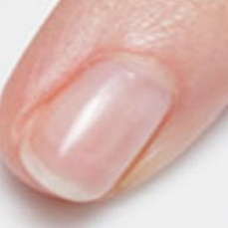  
normal#3 **Confidences:**normal = 100%; serious = 0%; non-serious = 0%;   
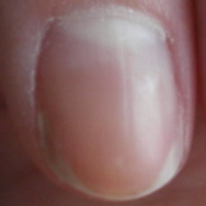  
normal#4 **Confidences:**normal = 100%; serious = 0%; non-serious = 0%;   
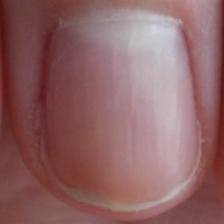  
normal#5 **Confidences:**normal = 100%; serious = 0%; non-serious = 0%;   
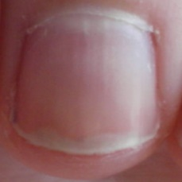  
normal#6 **Confidences:**normal = 100%; serious = 0%; non-serious = 0%;   
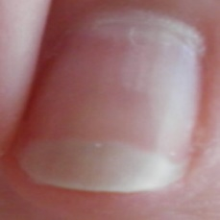  
normal#7 **Confidences:**normal = 100%; serious = 0%; non-serious = 0%;   
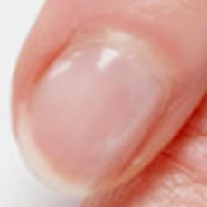  
normal#8 **Confidences:**normal = 80%; serious = 20%; non-serious = 0%;   
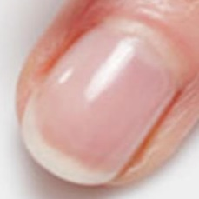  
normal#9 **Confidences:**normal = 100%; serious = 0%; non-serious = 0%;   
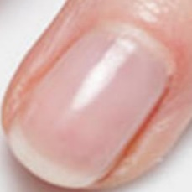  
normal#10 **Confidences:**normal = 100%; serious = 0%; non-serious = 0%;   
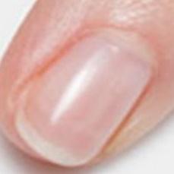  
normal#11 **Confidences:**normal = 100%; serious = 0%; non-serious = 0%;   
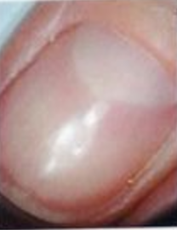  
normal#12 **Confidences:**normal = 40%; serious = 40%; non-serious = 20%;   
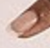  
normal#13 **Confidences:**normal = 100%; serious = 0%; non-serious = 0%;   
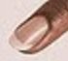  
normal#14 **Confidences:**normal = 100%; serious = 0%; non-serious = 0%;   
  
normal#15 **Confidences:**normal = 80%; serious = 0%; non-serious = 20%;   
  
normal#16 **Confidences:**normal = 80%; serious = 0%; non-serious = 20%;   
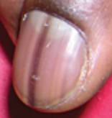  
normal#17 **Confidences:**normal = 100%; serious = 0%; non-serious = 0%;   
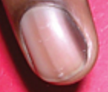  
normal#18 **Confidences:**normal = 100%; serious = 0%; non-serious = 0%;   
  
normal#19 **Confidences:**normal = 100%; serious = 0%; non-serious = 0%;   
  
normal#20 **Confidences:**normal = 100%; serious = 0%; non-serious = 0%;   
  
normal#21 **Confidences:**normal = 100%; serious = 0%; non-serious = 0%;   
  
normal#22 **Confidences:**normal = 100%; serious = 0%; non-serious = 0%;   
  
normal#23 **Confidences:**normal = 100%; serious = 0%; non-serious = 0%;   
  
normal#24 **Confidences:**normal = 100%; serious = 0%; non-serious = 0%;   
  
normal#25 **Confidences:**normal = 100%; serious = 0%; non-serious = 0%;   
  
normal#26 **Confidences:**normal = 100%; serious = 0%; non-serious = 0%;   
  
normal#27 **Confidences:**normal = 100%; serious = 0%; non-serious = 0%;   
  
normal#28 **Confidences:**normal = 100%; serious = 0%; non-serious = 0%;   
  
normal#29 **Confidences:**normal = 100%; serious = 0%; non-serious = 0%;   
  
normal#30 **Confidences:**normal = 100%; serious = 0%; non-serious = 0%;   
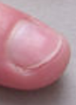  
normal#31 **Confidences:**normal = 100%; serious = 0%; non-serious = 0%;   
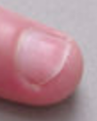  
normal#32 **Confidences:**normal = 100%; serious = 0%; non-serious = 0%;   
  
normal#33 **Confidences:**normal = 100%; serious = 0%; non-serious = 0%;   
  
normal#34 **Confidences:**normal = 100%; serious = 0%; non-serious = 0%;   
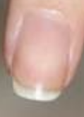  
normal#35 **Confidences:**normal = 100%; serious = 0%; non-serious = 0%;   
  
normal#36 **Confidences:**normal = 60%; serious = 40%; non-serious = 0%;   
  
normal#37 **Confidences:**normal = 60%; serious = 40%; non-serious = 0%;   
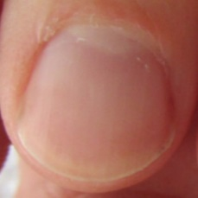  
normal#38 **Confidences:**normal = 100%; serious = 0%; non-serious = 0%;   
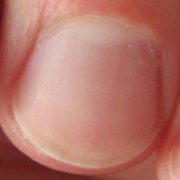  
normal#39 **Confidences:**normal = 100%; serious = 0%; non-serious = 0%;   
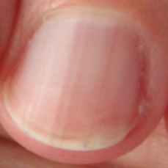  
normal#40 **Confidences:**normal = 100%; serious = 0%; non-serious = 0%;   
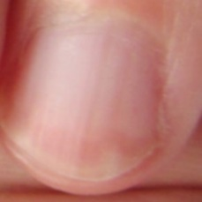  
normal#41 **Confidences:**normal = 100%; serious = 0%; non-serious = 0%;   
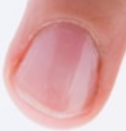  
normal#42 **Confidences:**normal = 100%; serious = 0%; non-serious = 0%;   
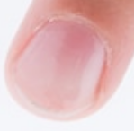  
normal#43 **Confidences:**normal = 80%; serious = 20%; non-serious = 0%;   
  
normal#44 **Confidences:**normal = 100%; serious = 0%; non-serious = 0%;   
  
normal#45 **Confidences:**normal = 100%; serious = 0%; non-serious = 0%;   
  
normal#46 **Confidences:**normal = 100%; serious = 0%; non-serious = 0%;   
  
normal#47 **Confidences:**normal = 100%; serious = 0%; non-serious = 0%;   
  
normal#48 **Confidences:**normal = 60%; serious = 40%; non-serious = 0%;   
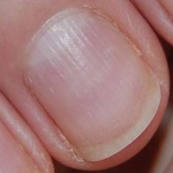  
normal#49 **Confidences:**normal = 80%; serious = 20%; non-serious = 0%;   
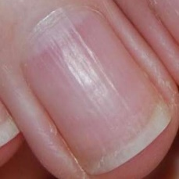  
normal#50 **Confidences:**normal = 100%; serious = 0%; non-serious = 0%;   
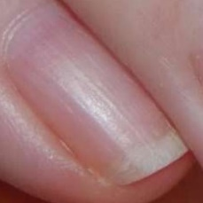  
normal#51 **Confidences:**normal = 80%; serious = 20%; non-serious = 0%;   
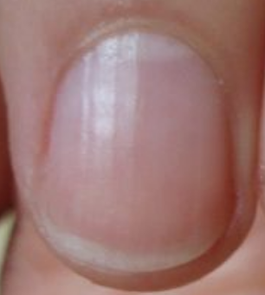  
normal#52 **Confidences:**normal = 100%; serious = 0%; non-serious = 0%;   
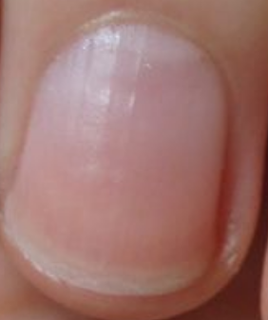  
normal#53 **Confidences:**normal = 100%; serious = 0%; non-serious = 0%;   
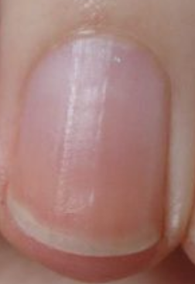  
normal#54 **Confidences:**normal = 100%; serious = 0%; non-serious = 0%;   
  
normal#55 **Confidences:**normal = 100%; serious = 0%; non-serious = 0%;   
  
normal#56 **Confidences:**normal = 100%; serious = 0%; non-serious = 0%;   
  
normal#57 **Confidences:**normal = 100%; serious = 0%; non-serious = 0%;   
  
normal#58 **Confidences:**normal = 100%; serious = 0%; non-serious = 0%;   
  
normal#59 **Confidences:**normal = 100%; serious = 0%; non-serious = 0%;   
  
normal#60 **Confidences:**normal = 100%; serious = 0%; non-serious = 0%;   
  
normal#61 **Confidences:**normal = 100%; serious = 0%; non-serious = 0%;   
  
normal#62 **Confidences:**normal = 100%; serious = 0%; non-serious = 0%;   
  
normal#63 **Confidences:**normal = 100%; serious = 0%; non-serious = 0%;   
  
normal#64 **Confidences:**normal = 100%; serious = 0%; non-serious = 0%;   
  
normal#65 **Confidences:**normal = 100%; serious = 0%; non-serious = 0%;   
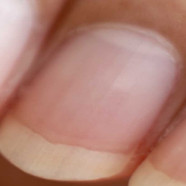  
normal#66 **Confidences:**normal = 100%; serious = 0%; non-serious = 0%;   
  
normal#67 **Confidences:**normal = 100%; serious = 0%; non-serious = 0%; 

Number whose highest confidence score is the correct answer = 68/68 (100%)

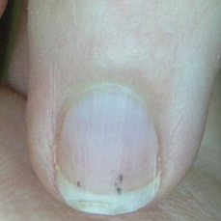  
serious#0 **Confidences:**normal = 20%; serious = 60%; non-serious = 20%;   
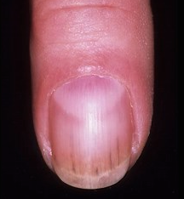  
serious#1 **Confidences:**normal = 20%; serious = 80%; non-serious = 0%;   
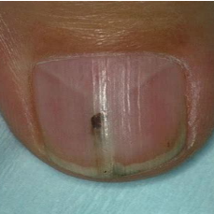  
serious#2 **Confidences:**normal = 0%; serious = 80%; non-serious = 20%;   
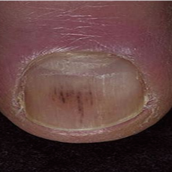  
serious#3 **Confidences:**normal = 40%; serious = 20%; non-serious = 40%;   
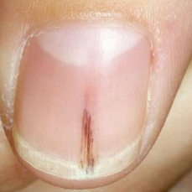  
serious#4 **Confidences:**normal = 60%; serious = 40%; non-serious = 0%;   
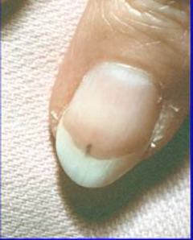  
serious#5 **Confidences:**normal = 0%; serious = 100%; non-serious = 0%;   
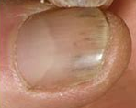  
serious#6 **Confidences:**normal = 0%; serious = 60%; non-serious = 40%;   
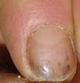  
serious#7 **Confidences:**normal = 0%; serious = 80%; non-serious = 20%;   
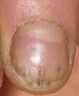  
serious#8 **Confidences:**normal = 0%; serious = 100%; non-serious = 0%;   
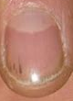  
serious#9 **Confidences:**normal = 20%; serious = 40%; non-serious = 40%;   
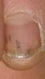  
serious#10 **Confidences:**normal = 0%; serious = 60%; non-serious = 40%;   
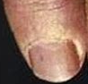  
serious#11 **Confidences:**normal = 0%; serious = 100%; non-serious = 0%;   
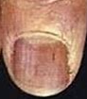  
serious#12 **Confidences:**normal = 0%; serious = 80%; non-serious = 20%;   
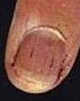  
serious#13 **Confidences:**normal = 0%; serious = 80%; non-serious = 20%;   
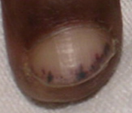  
serious#14 **Confidences:**normal = 0%; serious = 100%; non-serious = 0%;   
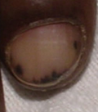  
serious#15 **Confidences:**normal = 0%; serious = 100%; non-serious = 0%;   
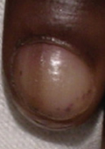  
serious#16 **Confidences:**normal = 0%; serious = 100%; non-serious = 0%;   
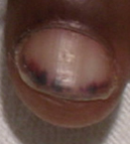  
serious#17 **Confidences:**normal = 0%; serious = 100%; non-serious = 0%;   
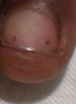  
serious#18 **Confidences:**normal = 0%; serious = 100%; non-serious = 0%;   
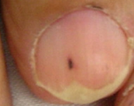  
serious#19 **Confidences:**normal = 0%; serious = 100%; non-serious = 0%;   
  
serious#20 **Confidences:**normal = 60%; serious = 40%; non-serious = 0%;   
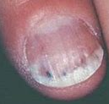  
serious#21 **Confidences:**normal = 40%; serious = 40%; non-serious = 20%;   
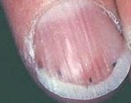  
serious#22 **Confidences:**normal = 60%; serious = 20%; non-serious = 20%;   
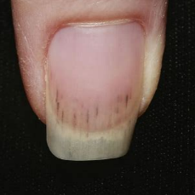  
serious#23 **Confidences:**normal = 0%; serious = 60%; non-serious = 40%;   
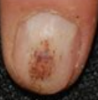  
serious#24 **Confidences:**normal = 20%; serious = 40%; non-serious = 40%;   
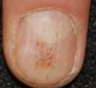  
serious#25 **Confidences:**normal = 0%; serious = 100%; non-serious = 0%;   
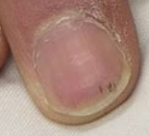  
serious#26 **Confidences:**normal = 0%; serious = 80%; non-serious = 20%;   
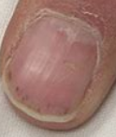  
serious#27 **Confidences:**normal = 0%; serious = 20%; non-serious = 80%;   
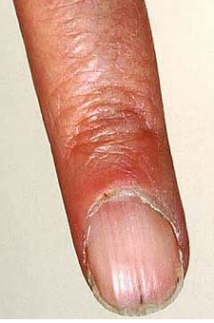  
serious#28 **Confidences:**normal = 0%; serious = 60%; non-serious = 40%;   
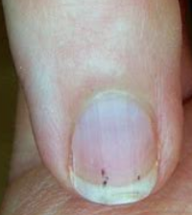  
serious#29 **Confidences:**normal = 0%; serious = 80%; non-serious = 20%;   
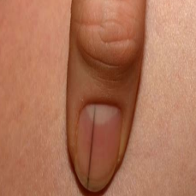  
serious#30 **Confidences:**normal = 0%; serious = 60%; non-serious = 40%;   
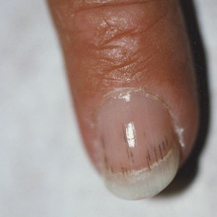  
serious#31 **Confidences:**normal = 0%; serious = 40%; non-serious = 60%;   
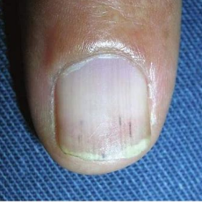  
serious#32 **Confidences:**normal = 0%; serious = 80%; non-serious = 20%;   
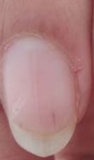  
serious#33 **Confidences:**normal = 20%; serious = 80%; non-serious = 0%;   
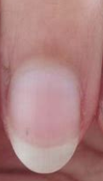  
serious#34 **Confidences:**normal = 20%; serious = 80%; non-serious = 0%;   
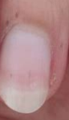  
serious#35 **Confidences:**normal = 20%; serious = 60%; non-serious = 20%;   
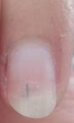  
serious#36 **Confidences:**normal = 20%; serious = 60%; non-serious = 20%;   
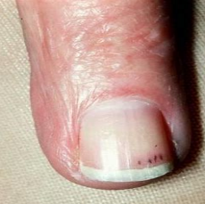  
serious#37 **Confidences:**normal = 20%; serious = 60%; non-serious = 20%;   
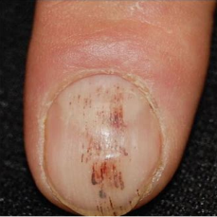  
serious#38 **Confidences:**normal = 0%; serious = 60%; non-serious = 40%;   
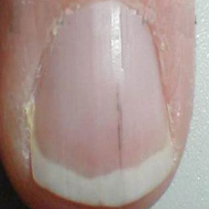  
serious#39 **Confidences:**normal = 20%; serious = 80%; non-serious = 0%;   
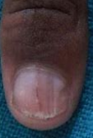  
serious#40 **Confidences:**normal = 40%; serious = 60%; non-serious = 0%;   
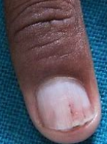  
serious#41 **Confidences:**normal = 0%; serious = 80%; non-serious = 20%;   
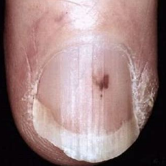  
serious#42 **Confidences:**normal = 0%; serious = 100%; non-serious = 0%; 

Number whose highest confidence score is the correct answer = 37/43 (86%)

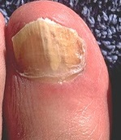  
non-serious#0 **Confidences:**normal = 0%; serious = 20%; non-serious = 80%;   
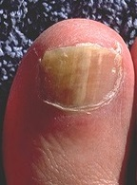  
non-serious#1 **Confidences:**normal = 60%; serious = 0%; non-serious = 40%;   
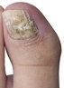  
non-serious#2 **Confidences:**normal = 0%; serious = 20%; non-serious = 80%;   
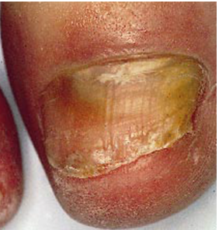  
non-serious#3 **Confidences:**normal = 0%; serious = 20%; non-serious = 80%;   
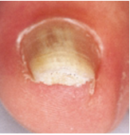  
non-serious#4 **Confidences:**normal = 0%; serious = 0%; non-serious = 100%;   
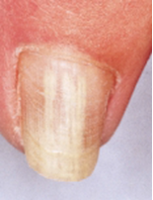  
non-serious#5 **Confidences:**normal = 0%; serious = 20%; non-serious = 80%;   
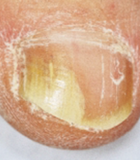  
non-serious#6 **Confidences:**normal = 0%; serious = 20%; non-serious = 80%;   
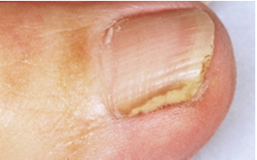  
non-serious#7 **Confidences:**normal = 0%; serious = 20%; non-serious = 80%;   
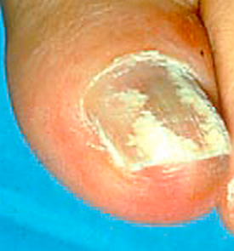  
non-serious#8 **Confidences:**normal = 0%; serious = 20%; non-serious = 80%;   
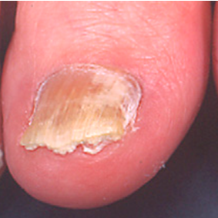  
non-serious#9 **Confidences:**normal = 0%; serious = 0%; non-serious = 100%;   
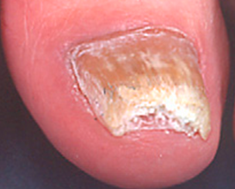  
non-serious#10 **Confidences:**normal = 0%; serious = 0%; non-serious = 100%;   
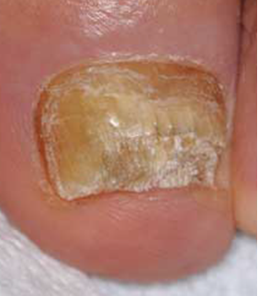  
non-serious#11 **Confidences:**normal = 0%; serious = 20%; non-serious = 80%;   
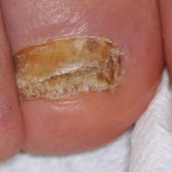  
non-serious#12 **Confidences:**normal = 0%; serious = 20%; non-serious = 80%;   
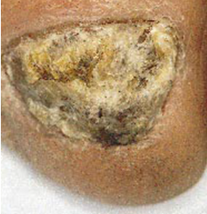  
non-serious#13 **Confidences:**normal = 0%; serious = 20%; non-serious = 80%;   
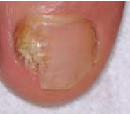  
non-serious#14 **Confidences:**normal = 0%; serious = 0%; non-serious = 100%;   
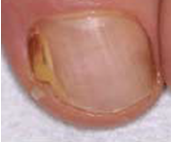  
non-serious#15 **Confidences:**normal = 0%; serious = 20%; non-serious = 80%;   
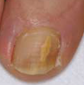  
non-serious#16 **Confidences:**normal = 0%; serious = 0%; non-serious = 100%;   
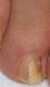  
non-serious#17 **Confidences:**normal = 0%; serious = 0%; non-serious = 100%;   
  
non-serious#18 **Confidences:**normal = 0%; serious = 0%; non-serious = 100%;   
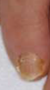  
non-serious#19 **Confidences:**normal = 0%; serious = 0%; non-serious = 100%;   
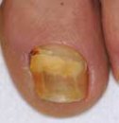  
non-serious#20 **Confidences:**normal = 20%; serious = 0%; non-serious = 80%;   
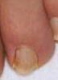  
non-serious#21 **Confidences:**normal = 0%; serious = 0%; non-serious = 100%;   
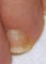  
non-serious#22 **Confidences:**normal = 0%; serious = 0%; non-serious = 100%;   
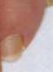  
non-serious#23 **Confidences:**normal = 0%; serious = 0%; non-serious = 100%;   
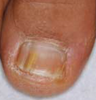  
non-serious#24 **Confidences:**normal = 0%; serious = 0%; non-serious = 100%;   
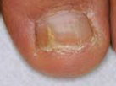  
non-serious#25 **Confidences:**normal = 0%; serious = 0%; non-serious = 100%;   
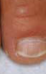  
non-serious#26 **Confidences:**normal = 0%; serious = 0%; non-serious = 100%;   
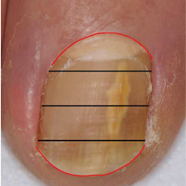  
non-serious#27 **Confidences:**normal = 0%; serious = 20%; non-serious = 80%;   
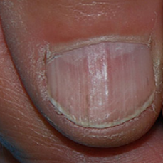  
non-serious#28 **Confidences:**normal = 0%; serious = 80%; non-serious = 20%;   
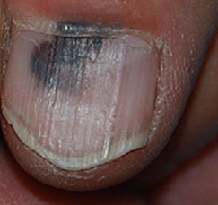  
non-serious#29 **Confidences:**normal = 40%; serious = 20%; non-serious = 40%;   
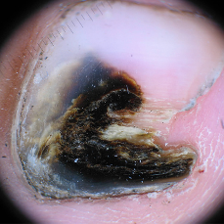  
non-serious#30 **Confidences:**normal = 0%; serious = 40%; non-serious = 60%;   
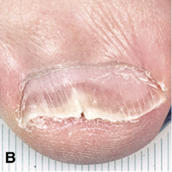  
non-serious#31 **Confidences:**normal = 0%; serious = 0%; non-serious = 100%;   
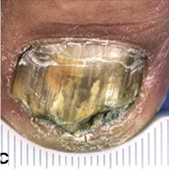  
non-serious#32 **Confidences:**normal = 0%; serious = 0%; non-serious = 100%;   
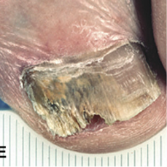  
non-serious#33 **Confidences:**normal = 0%; serious = 0%; non-serious = 100%;   
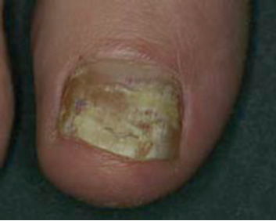  
non-serious#34 **Confidences:**normal = 0%; serious = 20%; non-serious = 80%;   
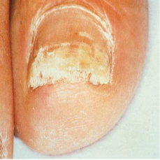  
non-serious#35 **Confidences:**normal = 0%; serious = 40%; non-serious = 60%;   
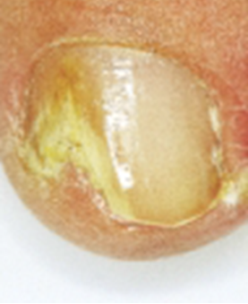  
non-serious#36 **Confidences:**normal = 0%; serious = 0%; non-serious = 100%;   
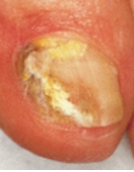  
non-serious#37 **Confidences:**normal = 0%; serious = 0%; non-serious = 100%;   
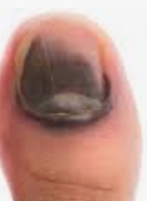  
non-serious#38 **Confidences:**normal = 40%; serious = 0%; non-serious = 60%;   
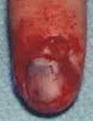  
non-serious#39 **Confidences:**normal = 0%; serious = 20%; non-serious = 80%;   
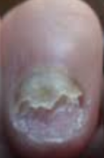  
non-serious#40 **Confidences:**normal = 0%; serious = 60%; non-serious = 40%;   
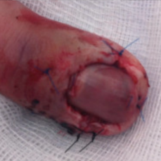  
non-serious#41 **Confidences:**normal = 40%; serious = 20%; non-serious = 40%;   
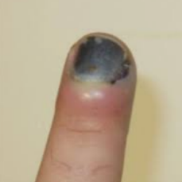  
non-serious#42 **Confidences:**normal = 20%; serious = 60%; non-serious = 20%;   
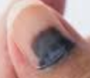  
non-serious#43 **Confidences:**normal = 80%; serious = 0%; non-serious = 20%;   
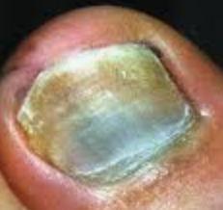  
non-serious#44 **Confidences:**normal = 0%; serious = 20%; non-serious = 80%;   
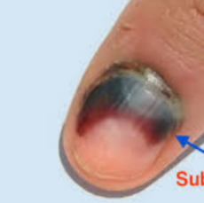  
non-serious#45 **Confidences:**normal = 20%; serious = 20%; non-serious = 60%;   
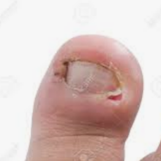  
non-serious#46 **Confidences:**normal = 0%; serious = 20%; non-serious = 80%;   
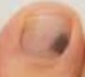  
non-serious#47 **Confidences:**normal = 60%; serious = 0%; non-serious = 40%;   
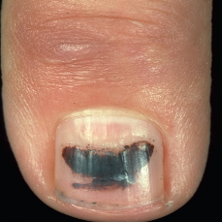  
non-serious#48 **Confidences:**normal = 0%; serious = 60%; non-serious = 40%; 

Number whose highest confidence score is the correct answer = 42/49 (86%)